**Design and Analysis of a Lower Limb Exoskeleton for elderly**

**ABSTRACT:**

In this paper a Lower Limb Exoskeleton was designed to assist elderly people during Sit-To-Stand cycle and walking, and it is tested for its structural strength. Static Structural Analysis is carried out in Ansys Workbench to find whether the design can withstand a load of 100 kg and maximum load it can withstand during the static condition. Modal Analysis is done to find the Natural frequency vibration of the design and the deformation of the exoskeleton with respect to the mode vibrations.

**I. INTRODUCTION**

Walking is a vital human function, it helps human beings to accomplish everyday tasks. Though gait in human beings looks lucid, it requires a cascade of neural and muscular interactions. Gait abnormalities will not only have negative effects on physical abilities but also on cognitive abilities. For instance, it will bring down the confidence levels of the person to complete day-to-day tasks and added to that low physical activity when compared with the food intake, may make the person obese [1]. Old people with gait disorders will have problems while standing and sitting and their gait pattern will also change to support weakened bones and muscles. According to a study on gait patterns in older adults, at 60, 85% of seniors have a normal gait and this percentage drops to 18% by age of 85. [2] There are many medical reasons for these gait disorders, one such reason is Osteoporosis. It is a condition where the bone density will get depleted with much more porous internal bone structure. This leads to reduced bone strength with more possibility of bone fractures due to falls. To reinforce the weakened bones during the sit-to-stand cycle and walking, external aids like walkers and crutches are used by elderly people. Though the crutches help in mobility, it will reduce the walking speed of the person and besides adds on more effort on Upper body. A much efficient way is to have an assistive device which reduces the wearer’s efforts on the upper body concomitantly obtaining better walking speeds. Since the major part of the muscles, nerves, bones, and tendons involved in the mobility are present in the lower body and to maximise the safety by reducing the accidents with environment and operator, an ideal exoskeleton design will be a Lower limb exoskeleton. The wearable Assistive Exoskeletons can solve the mobility problems in seniors to live without the physical help of other people [3]. With the rapid growth of study in the area of Human and Robot Interactions(HRI), distinct exoskeleton designs were developed relying on the type of movability problems. Exoskeletons are classified as Powered Exoskeletons, Passive Exoskeletons, Pseudo-Passive Exoskeletons, and Hybrid Exoskeletons which will be contingent on kind of driving mechanism and its functions. A Phenomenal amount of research work has been done on the area of Powered Exoskeletons differing from rehabilitation Exoskeletons like ReWalk to the Power-enhancing Exoskeletons like HAL [9] and BLEEX [8] by the HRI and robotic communities around the globe [4]. In this paper, the Assistive Exoskeleton design comes under the class of Powered Exoskeletons as it uses sensors, Actuators and Battery pack to power this unit. Powered exoskeletons are used widely in the case of Spinal Cord Injury (SCI). Some of the significant exoskeletons used for rehabilitation of the SCI people are Indego, ReWalk, EXO-H2. Indego is a lower limb exoskeleton for people with paralysis due to SCI designed by the researchers at Vanderbilt University. It supports people during the sit-to-stand cycle and walking along with the speed adjustments with a wireless software application developed by them [5]. ReWalk is lower extremity powered exoskeleton for people with completely paralyzed lower body. It has rehabilitation version with height and width adjustment, and a personal unit version which can be custom designed for a comfortable fit with the wearer body [6]. Exo-H2 is a powered exoskeleton which assists the people who partially lost their ability to walk. It uses Dc brushless motors coupled with Harmonic gear drive for actuation at all the six joints in the lower limb(Hip-Knee-Ankle) [7]. In this paper, the Assistive Exoskeleton is designed to help elderly to perform sit-to-stand cycle and stance-to-swing cycle during walking and the static structural analysis for this designed Exoskeleton is carried out using Ansys workbench. The design is tested to find whether it withstand a load of 100kg weight during static condition.

**II.a. Exoskeleton design requirements**

This is a Lower Limb exoskeleton covering Hip-Knee-Ankle joints designed to assist old people during the sit-to-stand cycle and walking. Before designing the exoskeleton, the exoskeleton requirements are found based on different studies. In this section, the design requirements and how they are considered is addressed and based on these requirements how the exoskeleton is designed in addressed in the next section.

***Age group and Anthropometric data***:

Mobility efficiency of a person can be evaluated by the walking speed and falls. According to [15,16], the research results show that the walking velocity decreases with the age making the gait less efficient. Tommy Oberg tested 233 healthy subjects for their walking speed with age ranging between 10 to 79 years [17]. Hageman [19], Finley [20], waters [21] have also done experiments to find the walking speed. The average of overall velocity results for different age groups and gender with reference to the above papers are given in table ().

**Walking speed comparison between young and elderly. Table. ()**

|  |  |  |
| --- | --- | --- |
| **Gender** | **Age** | **Velocity(m/s)** |
| Male | 20-38.5 | 1.30 |
| Male | 60-69 | 1.24 |
| Female | 20-40.1 | 1.23 |
| Female | 60-75 | 1.09 |

Studies show that about 33% of the elderly above 65 years are fall-prone and experience at least one falls per year and this percentage further increases above 80 years [18]. So, the selected age group in the design of exoskeleton is above 60 years. The anthropometric data considered for the design of exoskeleton is based on the results of this study done on Indian subjects [22]. The mean value and the maximum value are considered as the dimensional range and the data is given in the table ().

**Anthropometric data of Indian subjects. Table. ()**

|  |  |
| --- | --- |
| **Parameters** | **Range** |
| Weight(kg) | 60-94 |
| Acromial Height (cm) | 137.2-153.8 |
| Waist circumference (cm) | 80-110 |

***Gait dataset collection and Analysis***:

The experimental gait data that was considered for the analysis was collected by Jill Higginson and Chand John in the Neuromuscular Biomechanics Lab at the University of Delaware [23]. The data include marker trajectories and ground reaction forces for an unimpaired adult male of height 1.83m weighing 72.6 kg walking at a speed of 1.36 m/s on an instrumented split-belt treadmill. The motion data collected with the help of marker trajectories are used to compute the Joint angles using the Inverse Kinematics toolbox of OpenSim software. The Net Joint moments are computed by using the joint angles and ground reaction forces using the Inverse Dynamics toolbox of OpenSim software. The net Joint moments obtained for the above subject after solving the inverse dynamics problem is shown in the Figure.II(1), Figure.II(2), Figure.II(3) for Hip, Knee, and Ankle Joints respectively.

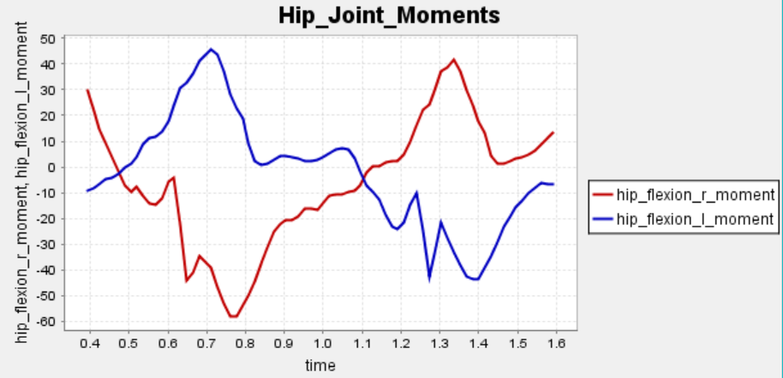

Figure.II(1)

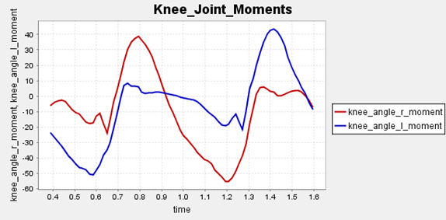

Figure.II(2)

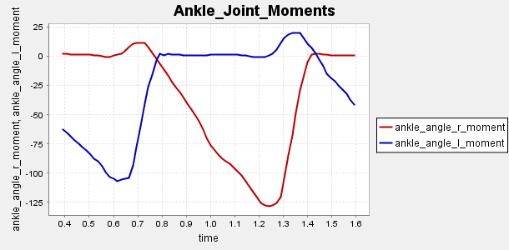

Figure. II (3)

From the plots, the Joint moments of Hip, Knee and Ankle joints can be found out which is varying depending on the postures at different point during the stance to swing phase. It is observed that for the same subject waking, there is difference in peak Joint moments between left and right leg which is due to the modelling and marker data processing error which is common due to the change in centre of mass during the motion capture. Based on the above plots the torques are considered to be ranging between 30 to 55 Nm. According to [11], it is empirically found that for one kilogram of body weight a torque of 1 Nm is required utmost at the hip joint and an average torque of 35 Nm is adequate for a normal person. So a torque of 35 Nm is considered for the exoskeleton design [28]. The data collected are not representatives of elderly who require assistance. However, the data is considered for finding the torques required to create by the actuators during walking.

**II.b. Design of Lower Limb Exoskeleton**

***Exoskeleton structural design:***

The exoskeleton was designed by considering the design requirements addressed in the previous section. This exoskeleton is designed for assistance of elderly people with a height between 137 cm to 158 cm and the waist circumference ranging between 80cm to 110 cm. The desired height and waist sizes can be adjusted by the wearer with the help of nut and bolt fastener adjustment provided at the Hip and Thigh frames, see Figure. II(b). BLEEX uses a hydraulic actuator mechanism with locks at the desired height [8]. Slotted bars with motor driven sliding pivot mechanism is available for better adjustments of actuators at the joints [25]. Both the systems are bulky and add on more weight to the exoskeleton. On considering the weight, design complexity and cost factors nut and bolt fasteners are used to keep the design simple and light weighted which is even cost effective. Velcro straps are provided making the design compact and comfortable for the wearer by taking ergonomics into consideration [10]. The battery pack and micro-controller unit are placed inside a back casing provided on the posterior side of the hip for proper stability and support to the spine, see Figure. II(c). By taking the Weight range data from the previous section i.e. 64 to 94 kg the exoskeleton is expected to carry a safe load of 100kg. The Static structural analysis is done in the next section () to find whether the exoskeleton design can withstand a load of 100kg.

***Material:***

The 7000 series aluminium is the strongest material in aluminium alloy. Especially, 7075 is super hard aluminium with good mechanical properties commonly used in aircraft structures and other high-stress structures requiring high strength and corrosion resistance. So, Aluminium 7075 T6 is chosen as the primary material for the structural design of Hip, Thigh, knee, Ankle and foot frames considering its high Yield strength and less density making it strong and lightweight material for the Exoskeleton.

***Actuators:***

This is an electrically actuated device with six degrees of freedom(DOF) in which the hip and knee are power actuated by the motors and ankle is kept free for dorsiflexion and plantarflexion with the help of bearing. The degrees of freedom are constrained to six degrees to reduce the design complexity and to keep the design simple and light weighted. Military purpose exoskeletons like BLEEX [8] and SARCOS [26] are developed to carry heavy weights with less efforts by the wearer and uses linear hydraulic actuators and rotary hydraulic actuators respectively. Comparatively electric actuators have higher power efficiency than the hydraulic actuators and in the case of this exoskeleton there is no need to carry relatively heavier loads [27]. Hydraulic actuators maintenance will be difficult because of its internal leakages and friction. So, it is best suitable to use electric actuators in this assistive exoskeleton. Harmonic gear drives of type CSD are coupled with the DC brushless motors are used to reduce the speed and increase the torques of the motor [14]. Harmonic gear drive has Zero backlash and high precision, making it the best suitable gear drive for the exoskeleton design. Harmonic gear drive comprises of three major parts Circular spline, Flex spline, and Wave Generator. Circular spline is fixed to the Hip and Thigh frames respectively, and the flex spline is a moving part which gives the output speed and Torque. Moreover, Dc brushless motors and Harmonic gear drive are selected because of its compactness and high reduction ratio in single stage. The DC brushless motor coupled with Harmonic Gear Drive will give net output Torque of 35 Nm and a peak torque of 180 Nm. This will satisfy the design requirement of the moment at the Joints while a normal person is walking, which is addressed in the previous section. The other exoskeletons for rehabilitation use motors even at the Ankle joint to create enough contact force on the ground by controlling the plantar and dorsiflexion of Ankle joint movements for improving the gait quality as the subject may be paraplegic or in the rehabilitation stage [12]. But in the case of an elderly person with osteoporosis, the subject is able to walk but have problems with the bone strength and gait patterns. So the muscle forces during the Hip and Knee flexion has to be reduced and the forces during the Ankle dorsiflexion and plantarflexion are neglected. So rather than using Dc brushless motors coupled with Harmonic gear drive, bearings are used for free movement of the Ankle joint. The entire Exoskeleton model is shown in Figure. II(a).

***Weight of the Exoskeleton:***

The structural weight of the exoskeleton obtained from the SolidWorks Mass properties is 11.6 kg. The weight of lithium polymer battery will be 1.5 kg and sensors; microcontrollers weights together adds another 1 kg. So the overall weight of this exoskeleton will be approximately 14 kg.

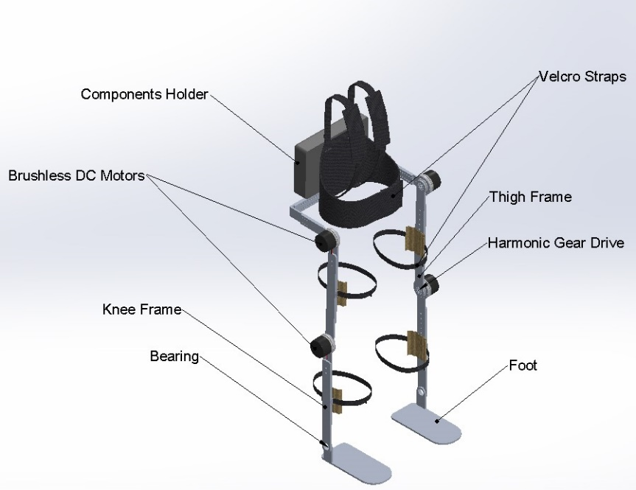

Figure. II(a). Assistive Exoskeleton Solidworks Model

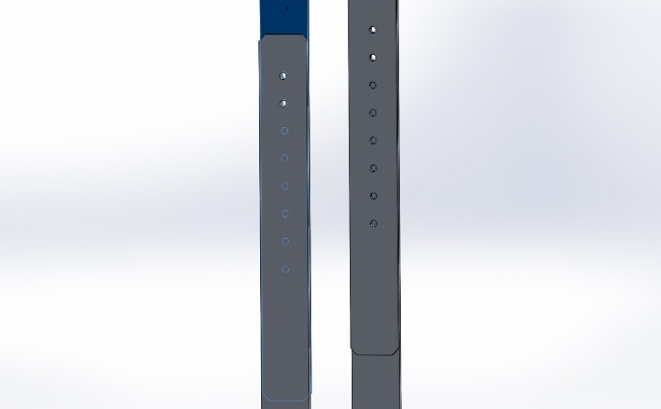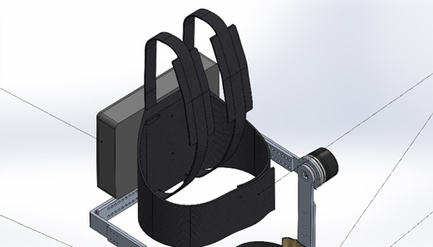

Figure. II(b). comfortable adjustment Figure. II(c). Back-casing for on board computer

**III. Static Structural Analysis of Exoskeleton**

**A. FULL EXOSKELTON:**

The Exoskeleton model was designed in SolidWorks and was imported to the Ansys Workbench in STEP file format for the Static Structural Analysis using Finite Element Method. The parts like motors, Velcro straps, component holder are removed during the analysis to reduce the problem solving time. These removed components make the problem overly defined and will not bring huge variation in the solution. Aluminium 7075 T6 is used as the material for the Hip, Knee, Ankle and Foot frames. 15-5 ph Stainless-steel is used as the material for the circular-spline of the Harmonic drive and Nitronic 60 stainless-steel for the Flex-spline of the Harmonic drive. The material properties for the Aluminium 7075 T6, Nitronic-60 Stainless steel,15-5 ph Stainless steel that is defined in the Ansys workbench is given in the Table III. (1).

**Table Material properties III. (1)**

(*source: ASM Handbook, Volume 1: Properties and Selection: Irons, Steels, and High-Performance Alloys and Metals Handbook, Vol.2 - Properties and Selection: Nonferrous Alloys and Special-Purpose Materials, ASM International 10th Ed. 1990.*)

|  |  |  |  |
| --- | --- | --- | --- |
| **Property** | **Aluminium 7075** | **Nitronic-60 stainless-steel** | **15-5 ph Stainless-steel** |
| Density(g/cc) | 2.81 | 7.58 | 8.01 |
| Yield strength (MPa) | 503 | 655 | 1070 |
| Young’s Modulus (GPa) | 71.7 | 179.2 | 200 |
| Poisson’s Ratio | 0.33 | 0.28 | 0.29 |
| Ultimate strength(MPa) | 572 | 758.42 | 1110 |

Meshing is done by selecting size function as Adaptive with Relevance value 40 in Ansys work bench. The analysis is done to check whether the structure is going to withstand a weight of 100 kg, so a force of 981N is applied on the Hip frame and the Left and Right are made as Fixed Support [13]. A moment of 35 Nm in positive z-direction is applied on the flex spine of the Harmonic drive at both Knee joints. A moment of 35 Nm in negative z-direction is applied on the flex spline of the Harmonic drive at both Hip joints. This is because the Harmonic drive is going to produce a maximum output torque of 35 Nm at the Hip and Knee joints. Standard Earth Gravity is also added to the design during the analysis. The d\sign setup along with the Forces and moments in Ansys Workbench is shown in the Figure III(a).

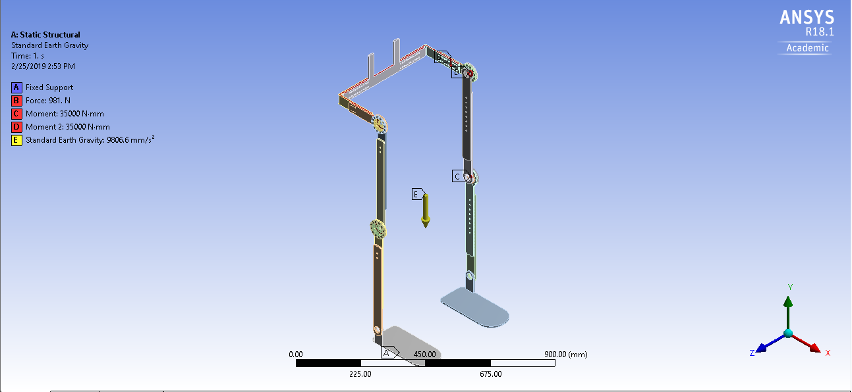

Figure. III(a). Exoskeleton Analysis boundary conditions

The solution for the Total Deformation and the Von-Missies stress is evaluated by solving the problem. A maximum deformation of 0.44mm is obtained as shown in the Figure III(b).The maximum stress of 382.15 MPa is acting on the flex spline which is less than the Yield strength of the 15-5 ph stainless-steel which is 1070 MPa, see Figure III(d). The place where the Maximum and Minimum stress are ac\tI(c). So the design is structurally strong and stable for a person of 100kg weight.

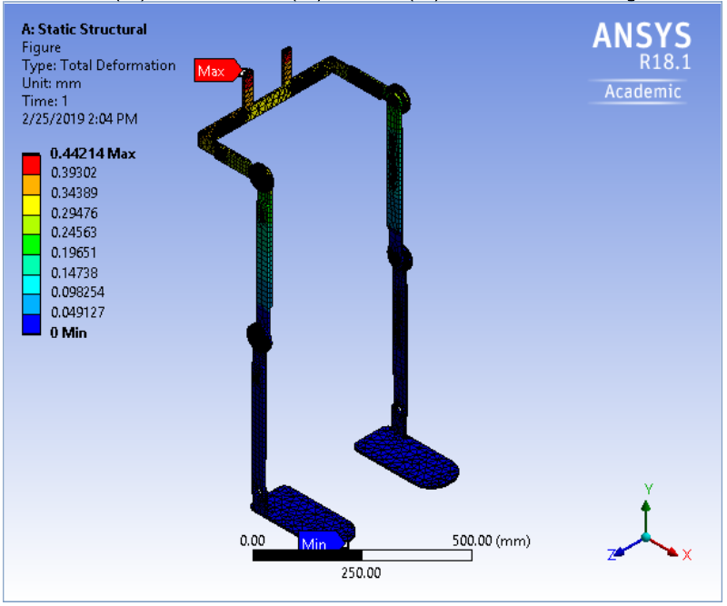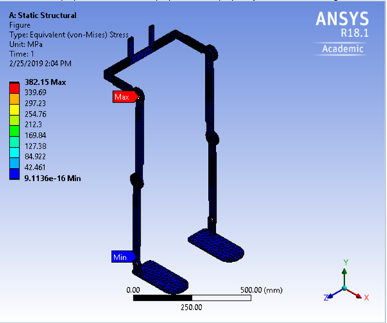

Figure. III(b). Deformation Results Figure. III(c). Stress distribution Results

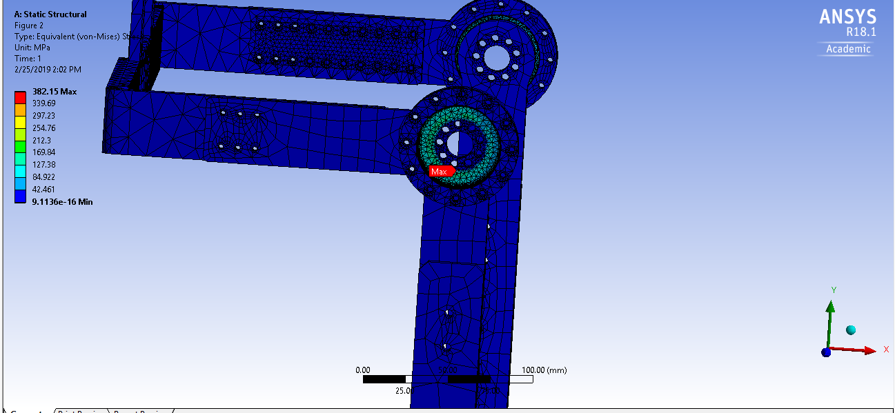

Figure. III(d). Max Stress acting Area

**B. Hip Frame:**

The Hip frame alone is imported into the Ansys workbench in STEP file format for Static Structural Analysis using Finite Element Method. Aluminium 7075 T6 is defined as the material for the Hip frame and a Force of 981N (100 kg weight) is applied on the Hip. The two ends of the Hip Frame are made as Fixed Supports. Standard gravitational Force is also added to the Hip frame during the Analysis. The design setup of the Hip frame along with the Forces and Fixed Supports in Ansys workbench before the analysis is shown in the Figure III.B.(a). This Analysis is being done to find the Total deformation of the Hip frame if a weight of 100 kg is acting on it during the fixed end condition. The Maximum stress acting on the frame during these conditions can also be analysed with respect to the Aluminium 7075 T6 properties.

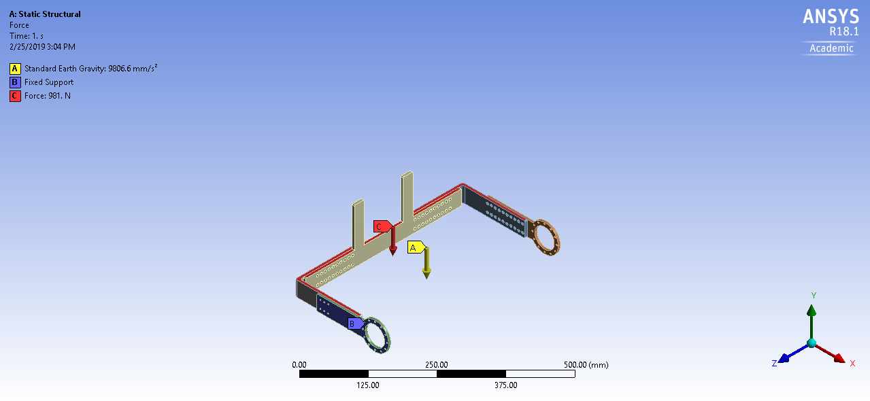

Figure. III.B.(a). Hip Analysis Boundary conditions

Solution for Total Deformation and Von-Misses stress is evaluated by solving the problem in Ansys Workbench. The max deformation of the Hip frame is 0.23 mm under these loading conditions. The area where the maximum deformation is obtained is shown in the Figure. III.B.(b). The maximum stress acting on the Hip frame structure is 27.12 MPa which is less than the Yield strength of Aluminium 7075 T6 i.e. 503 MPa. So the Hip frame is strong enough to withstand a load of 100kg. The area where the maximum stress is acting is shown in the Figure III.B.(c).

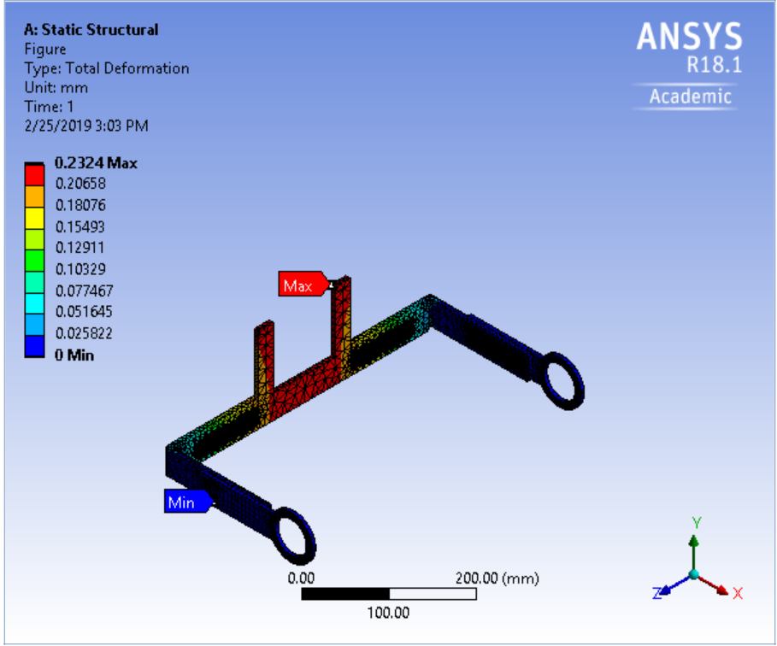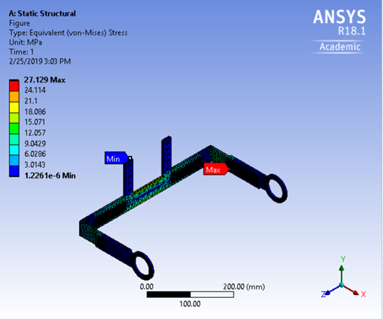Figure. III.B.(b). Deformation results of Hip Figure. III.B.(c). Stress distribution in Hip

**Ansys Workbench Result Table. (1)**

|  |  |  |  |  |
| --- | --- | --- | --- | --- |
| **Structure** | **Max.Deformation(mm)** | **Max.Stress**  **(MPa)** | **Min.Stress**  **(MPa)** | **Yield strength**  **(MPa)** |
| Full Exoskeleton | 0.44 | 382.15 | 9.11e-16 | 1070 |
| HIP Frame | 0.23 | 27.12 | 1.22e-6 | 503 |

***Maximum load capacity of the Exoskeleton:***

The maximum load the exoskeleton can withstand is found by solving the equivalent stress problem in Ansys workbench by gradually increasing the load on the Hip frame of the exoskeleton, see Table. ().

**Payload of the overall Exoskeleton**. Table. ()

|  |  |  |
| --- | --- | --- |
| **Force on Exoskeleton(N)** | **Max.Deformtion(mm)** | **Max.Stress(MPa)** |
| 1200 | 0.59 | 411.95 |
| 1500 | 0.63 | 514.16 |
| 2400 | 1.014 | 820.78 |
| 3000 | 1.26 | 1025.2 |

Maximum stress of 1025.2 MPa is acting on the flex spline of the exoskeleton when a load of 305 kg is acting on the hip frame. The yield strength of the 15-5 ph stainless-steel is 1070 MPa and if the weight more than 305 kg is added the stress will go beyond the yield strength and the structure will fail.

**Modal Analysis of the Exoskeleton**

The static structural Analysis of the Exoskeleton in the previsions section showed that the Exoskeleton is safe during the static conditions. The Exoskeleton is not static and contains moving parts and motors. The exoskeleton is not going to be constrained to the laboratory conditions, in the real time the exoskeleton has to deal with uneven ground surfaces and elevation walking which involves lot of external vibrations acting on it. So, it is always a good engineering practice to study the dynamic characteristics of the structure during the product development phase [24]. The Modal analysis is done to find the natural frequency vibrations of the structure and Mode shapes during different order of vibrations.

***Analysis Methodology***:

The Exoskeleton model designed in the SolidWorks is imported into Ansys Workbench in STEP file format. The components like motors and components holder are removed to save the problem solving time and not to overly define the problem. Aluminium 7075 T6 is assigned as the material for the structural frames of the exoskeleton and Nitronic-60 Stainless-steel, 15-5 Ph Stainless-steel is assigned as the material for the circular spline and the Flex spline of the Harmonic drive respectively. Software controlled Adaptive mesh is selected for the meshing of the exoskeleton and the sizing factor is set to medium in Ansys workbench. The left and right foot frames are made as fixed support and the modal analysis problem is solved.

***Modal Analysis results***:

The first six modes of Natural frequency vibrations values are shown in the table (). The deformation of the exoskeleton with respect to the order of vibration under no external force condition are shown in the figures ()

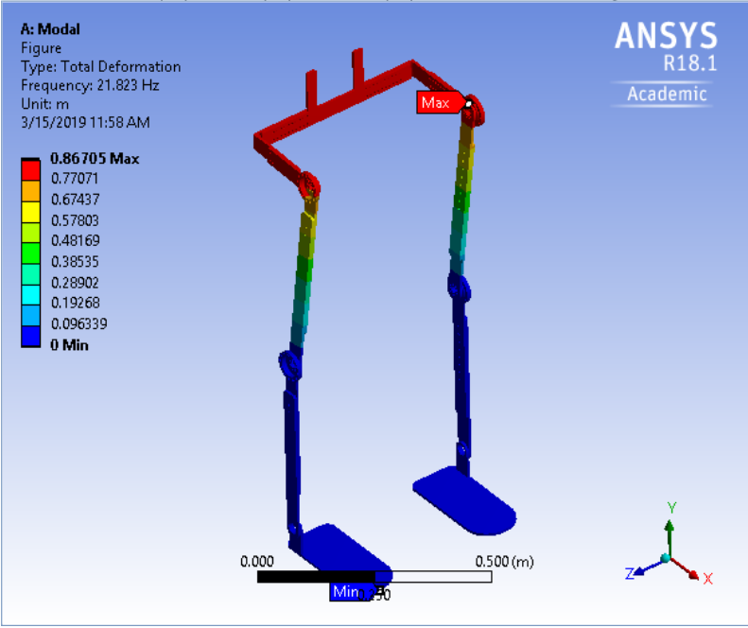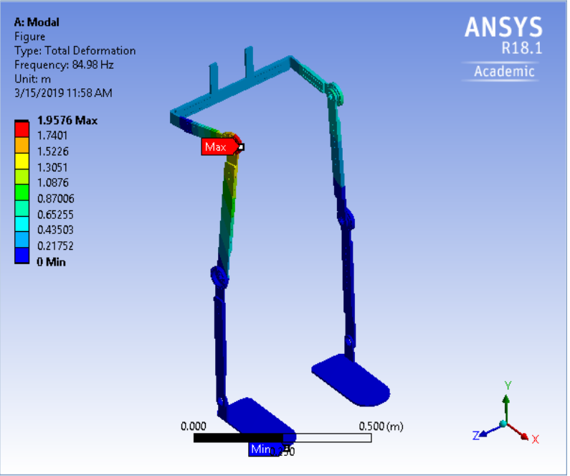

First order modal second order modal

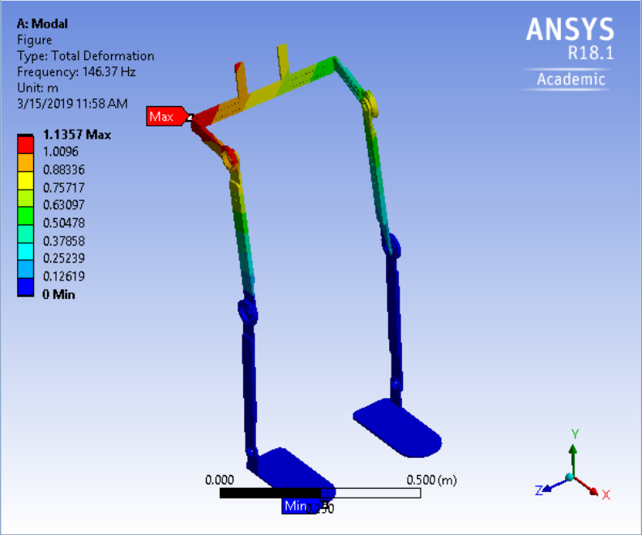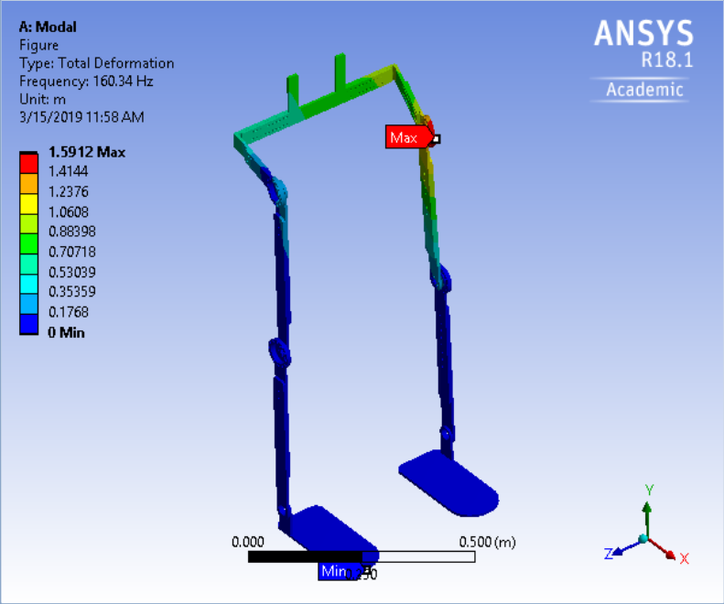

Third order modal fourth order modal

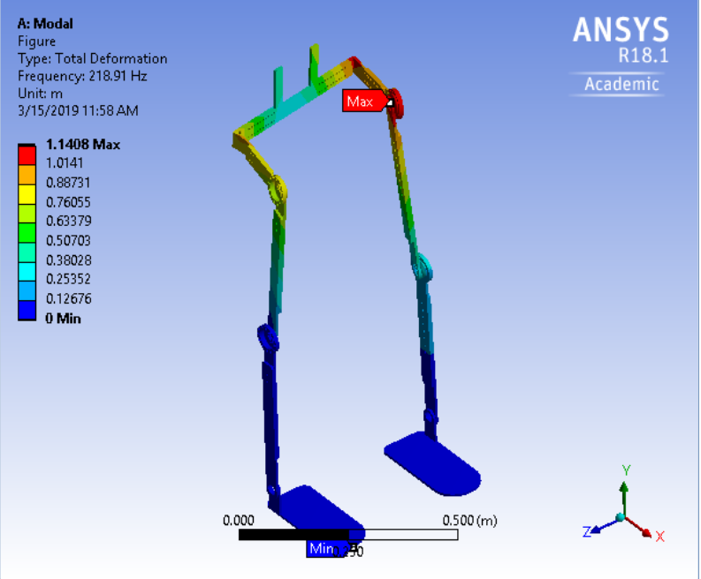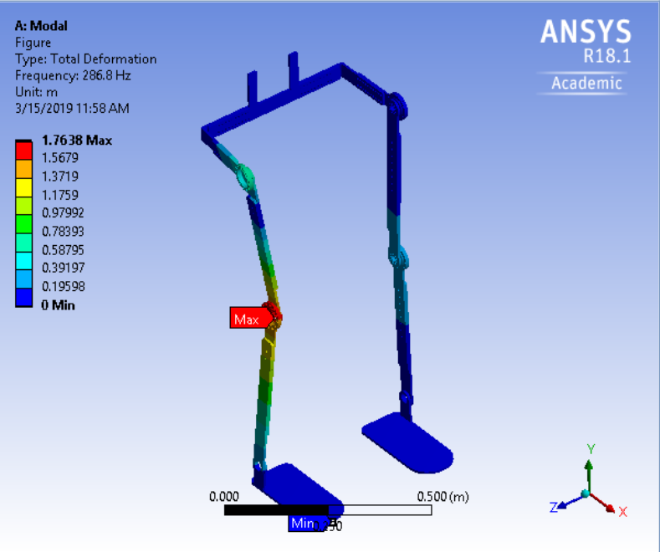

Fifth order modal sixth order modal

**Modal analysis frequency and vibration comparison** Table. ()

|  |  |  |
| --- | --- | --- |
| **Mode** | **Frequency(HZ)** | **MAX. Deformation(m)** |
| First order | 21.823 | 0.867 |
| Second order | 84.92 | 1.957 |
| Third order | 146.37 | 1.135 |
| Fourth order | 160.34 | 1.591 |
| Fifth order | 218.91 | 1.140 |
| Sixth order | 286.6 | 1.763 |

From the results it is found that if an external force creates vibrations on the exoskeleton at the range of natural frequency vibrations values of the modal analysis, resonance will occur. The resonance will damage the strength of the exoskeleton. The motor selected for this exoskeleton has a nominal speed of 3840 rpm which creates a forced vibrational frequency of 64 Hz on the structure. From the above modal analysis results it is found that the natural frequency of the exoskeleton is not in the range of 64 Hz which means the motor won’t create resonance. Likewise, the dynamic characteristics of the exoskeleton during the walking on rough terrains can be depicted from the above natural frequency vibrations range of values.

**Conclusion and Discussion:**

The lower limb exoskeleton is designed considering the Indian anthropometric data in the light of cost and lightweight simple design. The approximate weight of the exoskeleton is 14 kg and still, there is a vast room to maneuver on this factor. The Static Structural Analysis results show that on using Aluminium 7075 T6 as the primary material for the Exoskeleton, the design can withstand a load of 100kg. This analysis is done on both Full exoskeleton design and the Hip frame alone to compare and evaluate the Total deformation and stress distribution. This was done because in the case of Full exoskeleton the maximum stress is acting on the flex spline of the Harmonic drive. The flex spline is defined with the material 15-5 Ph stainless-steel which has a Yield strength of 1070 MPa. To study the behavior of Aluminium 7075 T6 under the loading conditions, individually the Hip fame is defined with aluminium and the analysis was done. The Hip frame analysis exhibits safe results making the aluminium 7075 T6 as suitable material for the exoskeleton design. On further loading of the exoskeleton with 120kg,150kg,245kg,305kg randomly in a gradually ascending order the maximum stress acting on the exoskeleton is 1025.2 MPa at 305 kg. If we further increase the load, the Maximum stress will be beyond the Yield strength of the 15-5 Ph stainless-steel i.e. 1070 MPa. So, the maximum load the exoskeleton can withstand during the static condition is 305 kg. But, by taking the factor of safety into consideration the maximum weight of the wearer is constrained to 100 kg, which will also satisfy the design requirements for the Indian subject mentioned in the design requirements section (). Modal analysis was done to find the natural frequency of the exoskeleton and the deformation of the exoskeleton with respect to mode frequency. This was done to find whether the selected motor will create a resonance, but the results show that the natural frequency vibration of the exoskeleton structure is not in the range of the forced vibrations created by the motor. So, the motor will not create any resonance with the exoskeleton structure. The design satisfied both static structural Analysis and Modal Analysis substantiating that the design is structurally safe.

**References:**

[1] Petri Wiklund, The role of physical activity and exercise in obesity and weight management: time for critical appraisal, *Journal of Sport and Health Science*,21 March 2016.

[2] Joe Verghese MD Aaron LeValley MA Charles B. Hall PhD Mindy J. Katz MPH Anne F. Ambrose MD Richard B. Lipton MD, Epidemiology of Gait Disorders in Community‐Residing Older Adults, *Journal of the American Geriatrics Society*, 19 December 2005.

[3]. Aveiro MC; Granito RN; Navega MTI; Driusso PI; Oishi J, Influence of a physical training program on muscle strength, balance and gait velocity among women with osteoporosis, Department of Physical Education, Center for Biological and Health Sciences, Federal University of São Carlos - UFSCar, São Carlos, SP – Brazil.

[4] Alberto Esquenazi MD Mukul Talaty PhD Arun Jayaraman PT, PhD, Powered Exoskeletons for Walking Assistance in Persons with Central Nervous System Injuries: A Narrative Review, 15 July 2016.

[5] Ryan J. Farris, Hugo A. Quintero, and Michael Goldfarb, Performance Evaluation of a Lower Limb Exoskeleton for Stair Ascent and Descent with Paraplegia, *34th Annual International Conference of the IEEE EMBS San Diego, California USA*, 1 September, 2012.

[6] Esquenazi, Alberto MD; Talaty, Mukul PhD; Packel, Andrew PT, NCS; Saulino, Michael MD, PhD, The ReWalk Powered Exoskeleton to Restore Ambulatory Function to Individuals with Thoracic-Level Motor-Complete Spinal Cord Injury, *American Journal of Physical Medicine & Rehabilitation*, November 2012.

[7] Magdo Bortole, Anusha Venkatakrishnan, Fangshi Zhu, Juan C Moreno, Gerard E Francisco, Jose L Pons and Jose L Contreras-Vidal, The H2 robotic exoskeleton for gait rehabilitation after stroke: early findings from a clinical study, *JOURNAL OF NEUROENGINEERING AND REHABILITATION*, 17 June 2015.

[8] Adam B. Zoss, H. Kazerooni, Member, IEEE, and Andrew Chu, Biomechanical Design of the Berkeley Lower Extremity Exoskeleton (BLEEX), *IEEE/ASME TRANSACTIONS ON MECHATRONICS*. 2, APRIL 2006.

[9] Atsushi Tsukahara; Yasuhisa Hasegawa; Kiyoshi Eguchi; Yoshiyuki Sankai, Restoration of Gait for Spinal Cord Injury Patients Using HAL with Intention Estimator for Preferable Swing Speed, *IEEE Transactions on Neural Systems and Rehabilitation Engineering*, 23 October 2014.

[10] Yeo Wei Hong, Yeong-Jin King, Wei-Hong Yeo, Chen-Hunt Ting, Yea-Dat Chuah, Jer-Vui Lee and Eu-Tjin Chok, Lower Extremity Exoskeleton: Review and Challenges Surrounding the Technology and its Role in Rehabilitation of Lower Limbs, *Australian Journal of Basic and Applied Sciences*,2013.

[11] Gery Colombo, MS; Matthias Joerg, MS; Reinhard Schreier, BNIE, Volker Dietz, MD, Treadmill training of paraplegic patients using a robotic orthosis, *Journal of Rehabilitation Research and Development*, 6, December 2000.

[12] Jan F. Veneman, Rik Kruidhof, Edsko E. G. Hekman, Ralf Ekkelenkamp, Edwin H. F. Van Asseldonk, and Herman van der Kooij, Design and Evaluation of the LOPES Exoskeleton Robot for Interactive Gait Rehabilitation, *IEEE TRANSACTIONS ON NEURAL SYSTEMS AND REHABILITATION ENGINEERING*, 3, SEPTEMBER 2007.

[13] Mei-Cheng Li, Li-Rong Wang, Dai-Min Chen, Jing-Jing Tao, Dong Chen, The Static Analysis of Wearable Lower Extremity Exoskeleton Based on ANSYS Workbench*, 2013 IEEE 9th International Conference on Mobile Ad-hoc and Sensor Networks*, 30 January 2014.

[14] ADAM ZOSS and H. KAZEROONI, Design of an electrically actuated lower extremity exoskeleton, 27 March 2006.

[15] Hageman P A, Blanke D J. Comparison of gait of young women and elderly women. Ph.vs Ther 1986; 66: 1382- 1387.

[16] Winter D A,The Biomechanics and Motor Control of Human Gait: Normal, Elderly and Pathological, *2nd edition. Waterloo: University of Waterloo Press*, 1991.

[17] Oberg T, Karsznia A. ijberg K;Basic parameters: Reference data for normal subjects. IO-79 years of age *Rehabil Res Dev 1993*.

[18] Prudham D, Evans J G; Factors associated with falls in the elderly: a community study; Age Ageing 1981.

[19] Hageman P A;Gait characteristics of healthy elderly: a literaturereview; Issues Aging 1995; 18: 14- 17.

[20] Finley F R, Cody K A, Finizie R V; Locomotion patterns in elderly women; Arch Phys Med Rehabil 1969; 50: 140-146.

[21] Waters R L, Lunsford B R, Perry J. Byrd R; Energy-speed relationship of walking: standard tables; J Orthop Res 1988; 6:2155222.

[22] Joydeep Majumder; Anthropometric dimensions among Indian males — A principal component analysis; *Eurasian Journal of Anthropology*; October 18, 2014.

[23] Chand T. John, Frank C. Anderson, Jill S. Higginson & Scott L. Delp (2012): Stabilisation of walking by intrinsic muscle properties revealed in a three-dimensional muscle-driven simulation*, Computer Methods in Biomechanics and Biomedical Engineering,* 06 Jan 2012*.*

[24] Gao Dongqiang,Tian Zhenya,Hao Dajian,Yao Sufen;Dynamic Characteristics Analysis of Leading Screw Based on ANSYS Software[J];*Hoisting and Conveying Machinery*,2008(11):54-57.

[25] Manuel Cestari, Daniel Sanz-Merodio, Juan Carlos Arevalo, and Elena Garcia; An Adjustable Compliant Joint for Lower-Limb Exoskeletons; *IEEE/ASME TRANSACTIONS ON MECHATRONICS,*5 June,2014.

[26] Susan Karlin; Raiding Iron Man's closet [Geek Life]; *IEEE Spectrum;* 22 July 2011.

[27] Weiguang Huo, Samer Mohammed, Juan C. Moreno, and Yacine Amirat; Lower Limb Wearable Robots for Assistance and Rehabilitation: A State of the Art; *IEEE SYSTEMS JOURNAL*; 20 October 2014.

[28] Hiroaki Kawamoto,Yoshiyuki Sankai; Power Assist System HAL-3 for Gait Disorder Person; *International Conference on computers for Handicapped persons*; 04 July 2002.